ASSIGNMENT-2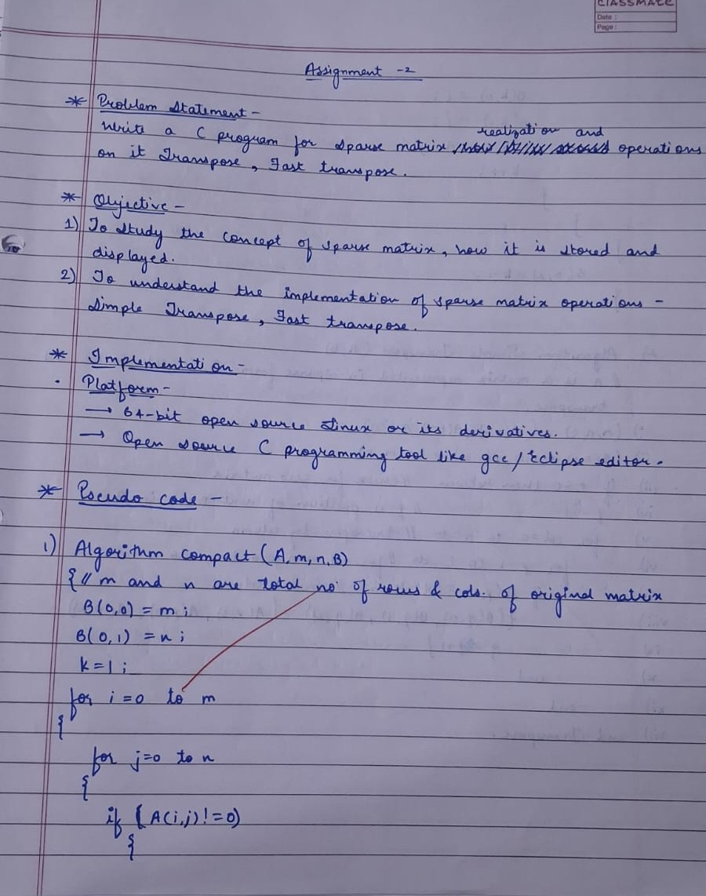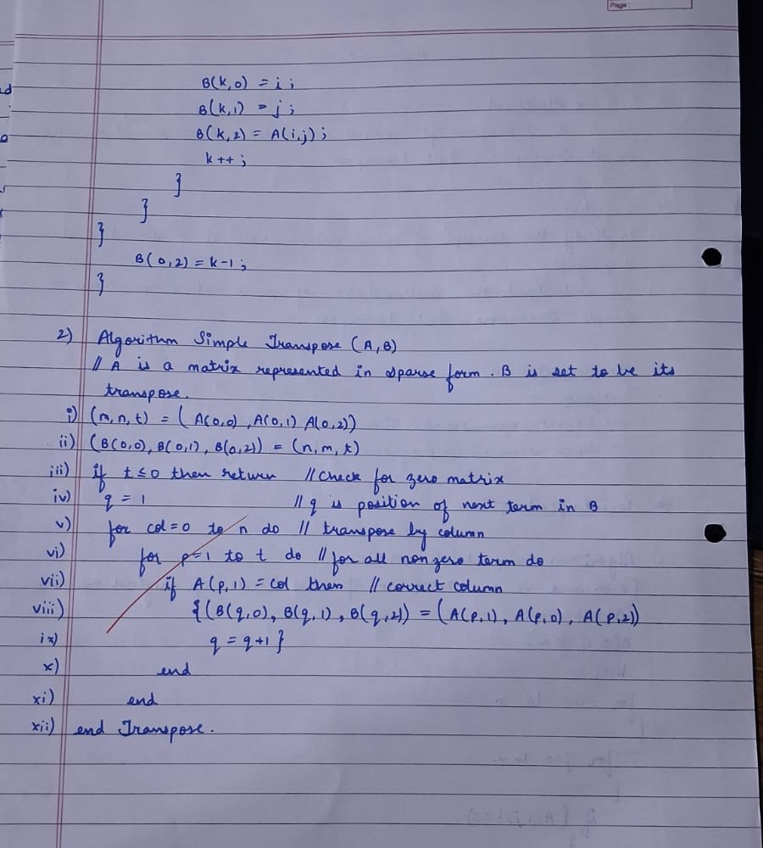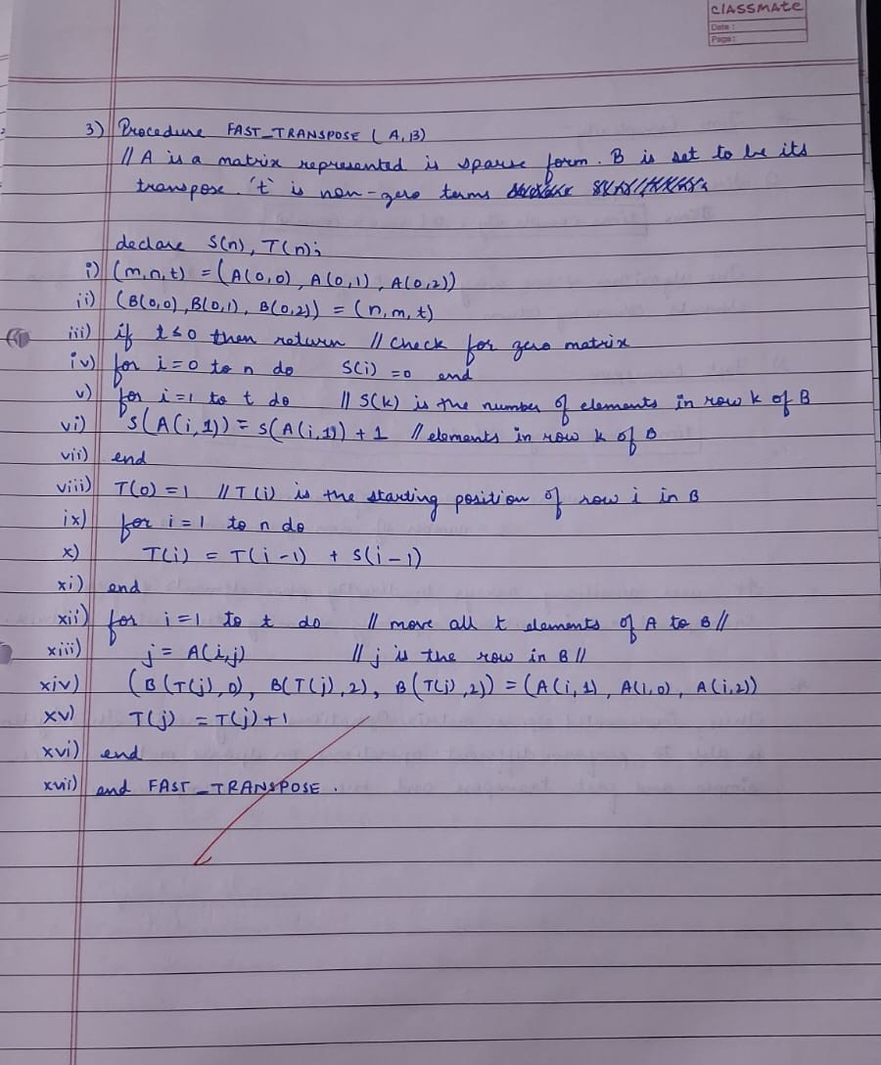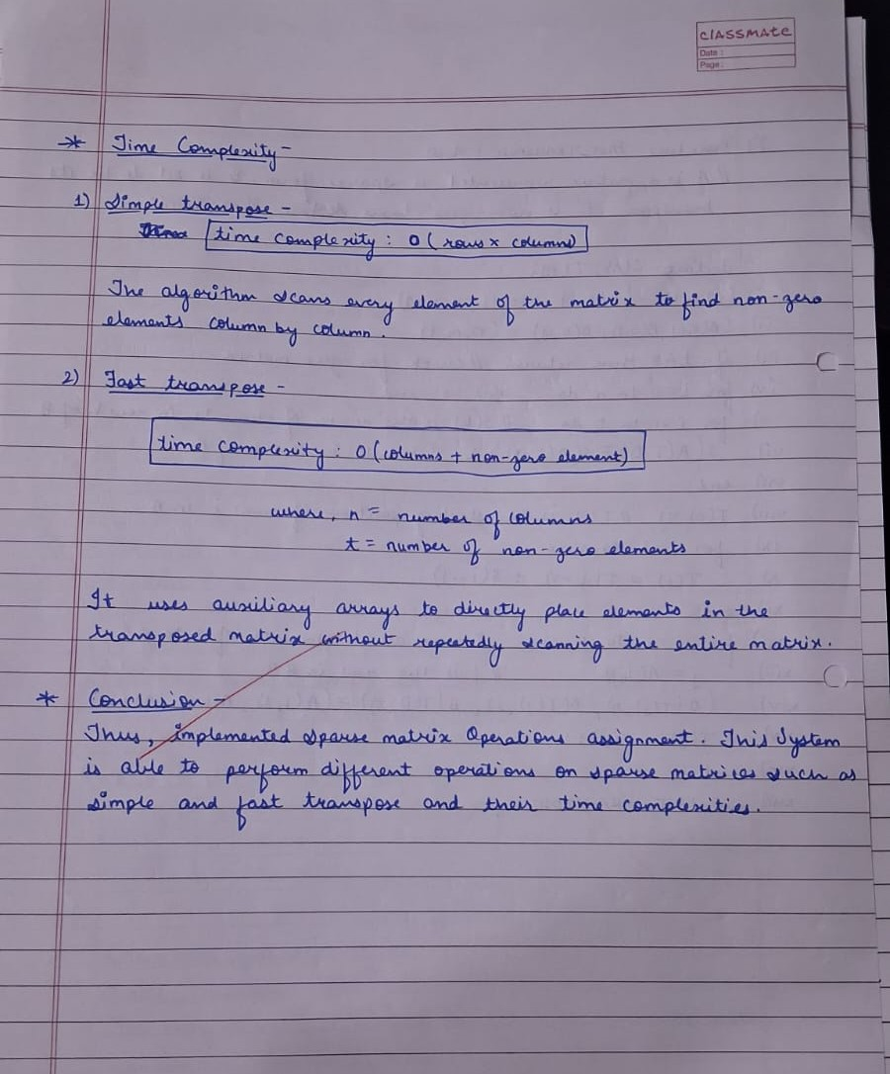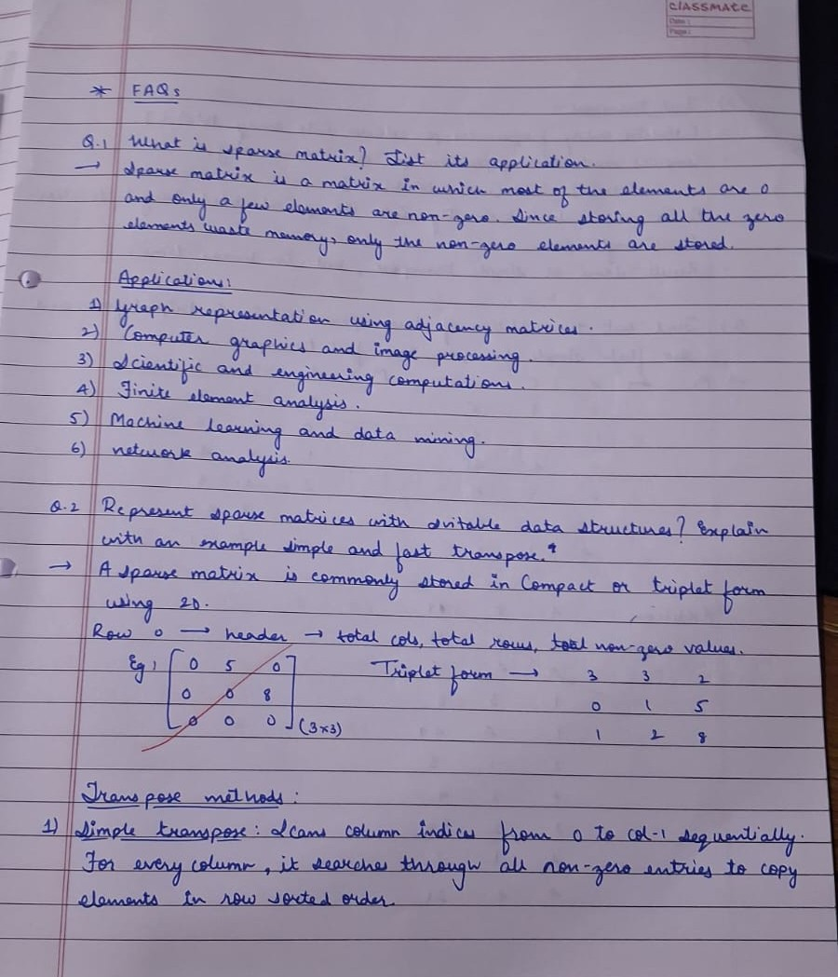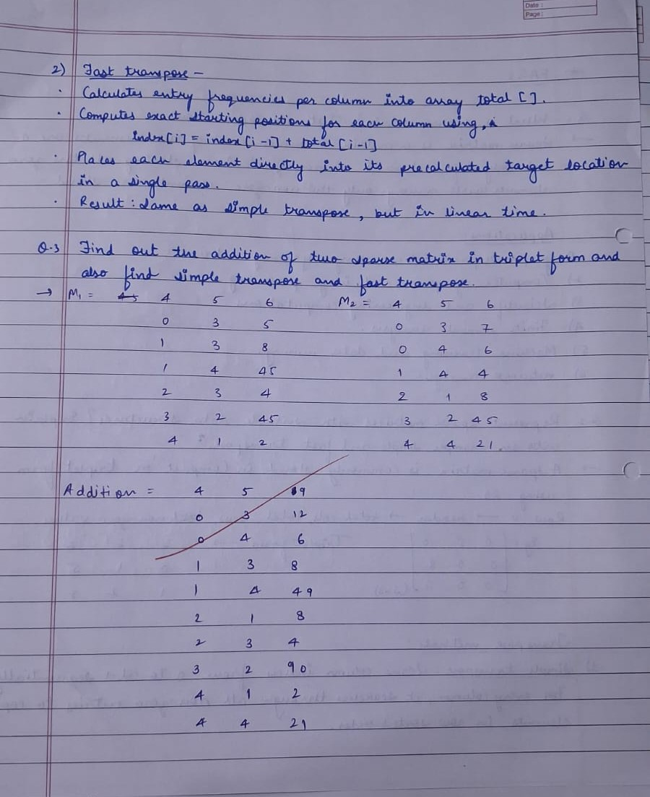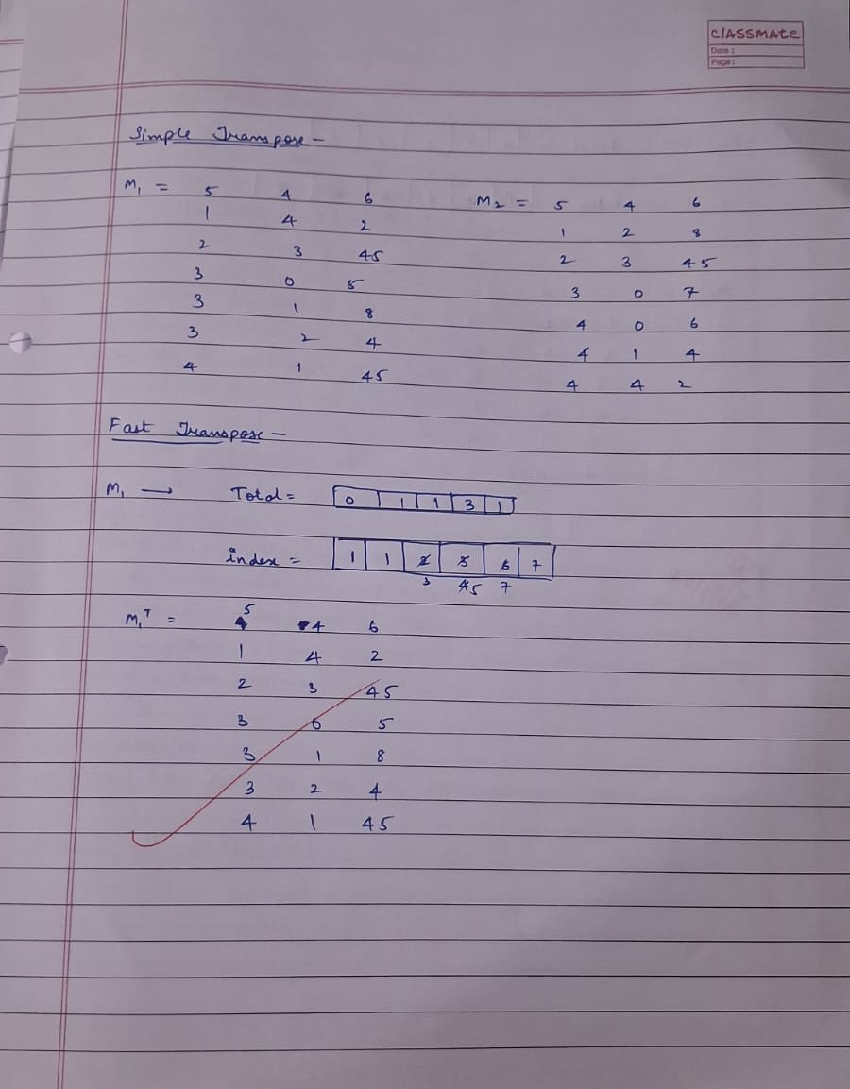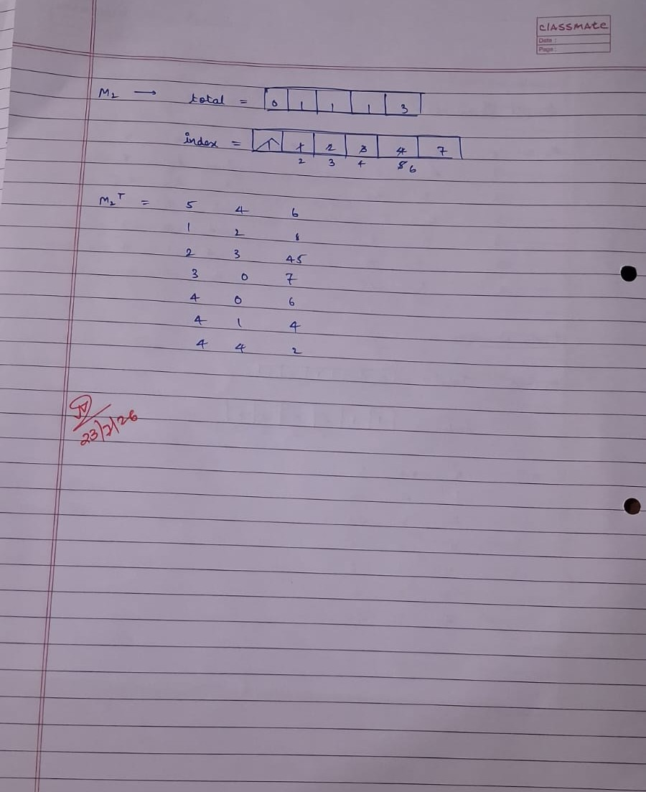

CODE:
#include <stdio.h>
#define MAX 100

void read(int rows, int cols, int matrix[MAX][MAX]);
void convert(int rows, int cols, int matrix[MAX][MAX], int compact[MAX][3]);
void display(int compact[MAX][3]);
void simple(int compact[MAX][3], int trans[MAX][3]);
void fast(int compact[MAX][3], int trans[MAX][3]);

int main()
{
int matrix[MAX][MAX];
int compact[MAX][3];
int trans[MAX][3];
int rows, cols;
int choice;

printf("Enter number of rows and columns: ");
scanf("%d %d", &rows, &cols);
read(rows, cols, matrix);

convert(rows, cols, matrix, compact);
printf("\nCompact Form: ");
display(compact);

printf("\nChoose Transpose Method:\n");
printf("1. Simple Transpose\n");
printf("2. Fast Transpose\n");

printf("Enter your choice (1 or 2): ");
scanf("%d", &choice);

switch (choice)
{
case 1: simple(compact, trans);
printf("\nResult: ");
display(trans);
break;

case 2: fast(compact, trans);
printf("\nResult: ");
display(trans);
break;

default: printf("\nInvalid choice!\n");
break;
}

return 0;
}

void read(int rows, int cols, int matrix[MAX][MAX])
{
printf("Enter matrix elements: \n");
for (int i=0; i<rows; i++)
{
for (int j=0; j<cols; j++)
{
scanf("%d", &matrix[i][j]);
}
}
}

void convert(int rows, int cols, int matrix[MAX][MAX], int compact[MAX][3])
{
int k = 1;
for (int i=0; i<rows; i++)
{
for (int j=0; j<cols; j++)
{
if (matrix[i][j]!=0)
{
compact[k][0] = i;
compact[k][1] = j;
compact[k][2] = matrix[i][j];
k++;
}
}
}
compact[0][0] = rows;
compact[0][1] = cols;
compact[0][2] = k - 1;
}

void display(int compact[MAX][3])
{
printf("\nRow\tCol\tValue\n");
for (int i=0; i<=compact[0][2]; i++)
{
printf("%d\t%d\t%d\n", compact[i][0], compact[i][1], compact[i][2]);
}
}

void simple(int compact[MAX][3], int trans[MAX][3])
{
int totalCols = compact[0][1];
int totalVal = compact[0][2];
int k = 1;
trans[0][0] = compact[0][1];
trans[0][1] = compact[0][0];
trans[0][2] = totalVal;
for (int i=0; i<totalCols; i++)
{
for (int j=1; j<=totalVal; j++)
{
if (compact[j][1] == i)
{
trans[k][0] = compact[j][1];
trans[k][1] = compact[j][0];
trans[k][2] = compact[j][2];
k++;
}
}
}
}

void fast(int compact[MAX][3], int trans[MAX][3])
{
int loc, i, col_no;
int columns = compact[0][1];
int non_zeros = compact[0][2];
int total[MAX];
int index[MAX];
for (i=0; i<columns; i++)
{
total[i] = 0;
}
for (i=1; i<=non_zeros; i++)
{
col_no = compact[i][1];
total[col_no]++;
}
index[0] = 1;
for (i=1; i<=columns; i++)
{
index[i] = index[i - 1] + total[i - 1];
}
trans[0][0] = compact[0][1];
trans[0][1] = compact[0][0];
trans[0][2] = compact[0][2];
for (i=1; i<=non_zeros; i++)
{
col_no = compact[i][1];
loc = index[col_no];
trans[loc][0] = compact[i][1];
trans[loc][1] = compact[i][0];
trans[loc][2] = compact[i][2];
index[col_no]++;
}
}

OUTPUT:
